# **Name: Abdurrahman Qureshi**

# **Roll No: 242466**

Practical No: 10

1) Write a program to demonstrate GUI of a Login page using JAVA FX

LOGIN PAGE

package com.example.demo;  
  
import javafx.application.Application;  
import javafx.fxml.FXMLLoader;  
import javafx.scene.Scene;  
import javafx.scene.control.*;  
import javafx.scene.layout.GridPane;  
import javafx.stage.Stage;  
  
import java.io.IOException;  
  
public class HelloApplication extends Application {  
 @Override  
 public void start(Stage stage) throws IOException {  
 stage.setTitle("Login Page");  
  
 Label labelUsername = new Label("Username:");  
 Label labelPassword = new Label("Password:");  
 TextField textFieldUsername = new TextField();  
 PasswordField passwordField = new PasswordField();  
 Button buttonLogin = new Button("Login");  
 Button buttonReset = new Button("Reset");  
  
 GridPane gridPane = new GridPane();  
 gridPane.setHgap(10);  
 gridPane.setVgap(10);  
 gridPane.add(labelUsername, 0, 0);  
 gridPane.add(textFieldUsername, 1, 0);  
 gridPane.add(labelPassword, 0, 1);  
 gridPane.add(passwordField, 1, 1);  
 gridPane.add(buttonLogin, 0, 2);  
 gridPane.add(buttonReset, 1, 2);  
  
 buttonLogin.setOnAction(e -> {  
 String username = textFieldUsername.getText();  
 String password = passwordField.getText();  
  
 if (username.equals("qarq90") && password.equals("iLoveGymMommies")) {  
 Alert alert = new Alert(Alert.AlertType.INFORMATION, "Login Successful!");  
 alert.show();  
 } else {  
 Alert alert = new Alert(Alert.AlertType.ERROR, "Invalid Username or Password");  
 alert.show();  
 }  
 });  
  
 buttonReset.setOnAction(e -> {  
 textFieldUsername.clear();  
 passwordField.clear();  
 });  
  
 Scene scene = new Scene(gridPane, 300, 150);  
 stage.setScene(scene);  
 stage.show();  
 }  
  
 public static void main(String[] args) {  
 launch();  
 }  
}

OUTPUT

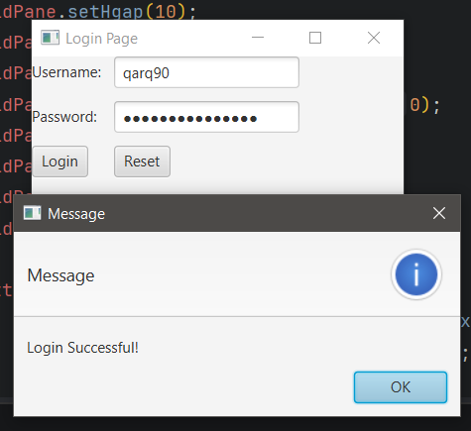 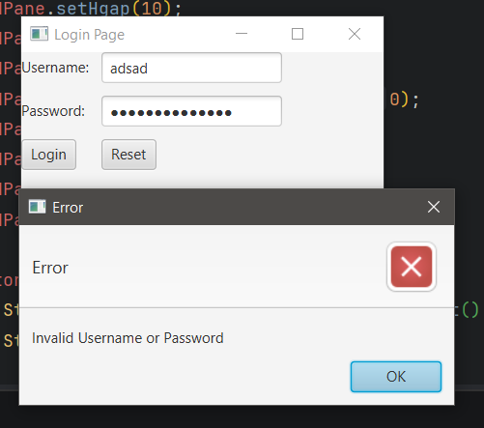

2) Write a program to demonstrate GUI of a banking application using JAVA FX

ORIGINAL DATABASE TABLE

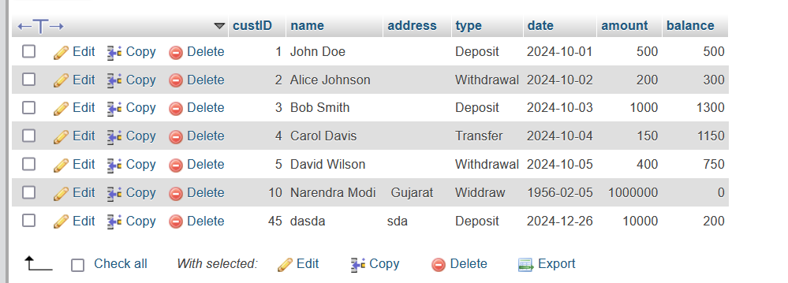

ADDING A CUSTOMER

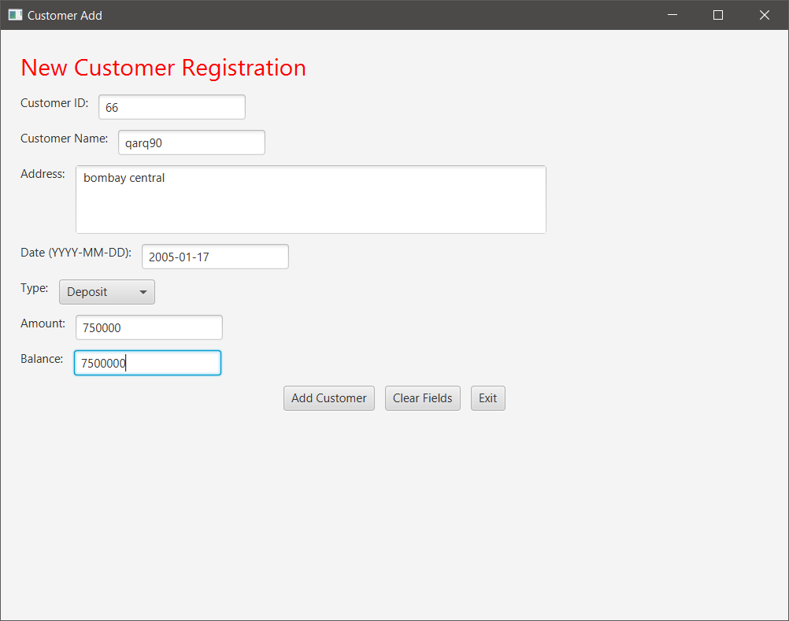

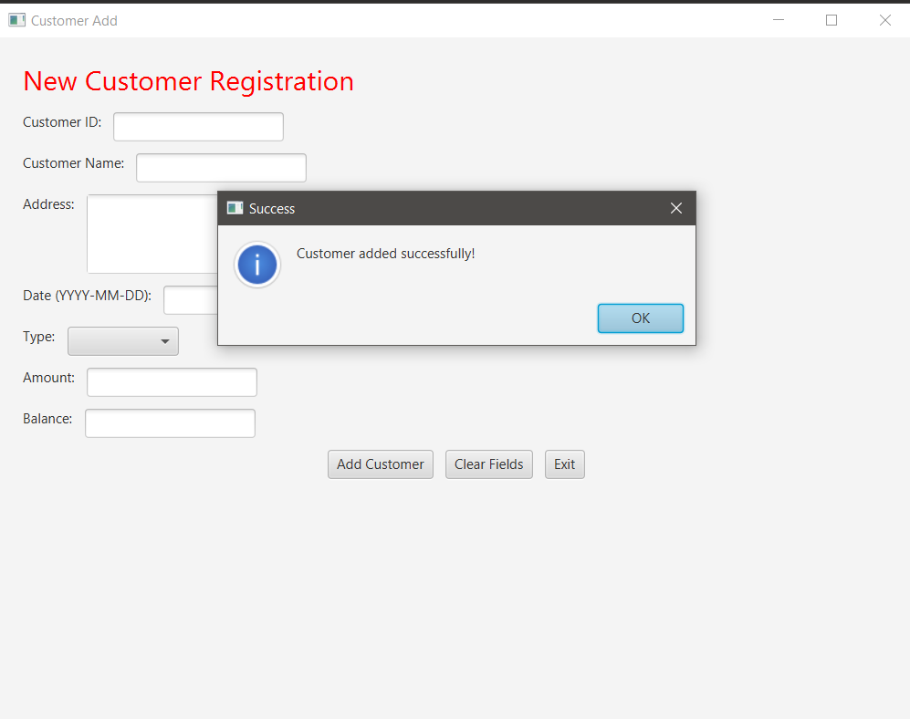

AFTER ADDING - ORIGINAL DATABASE TABLE

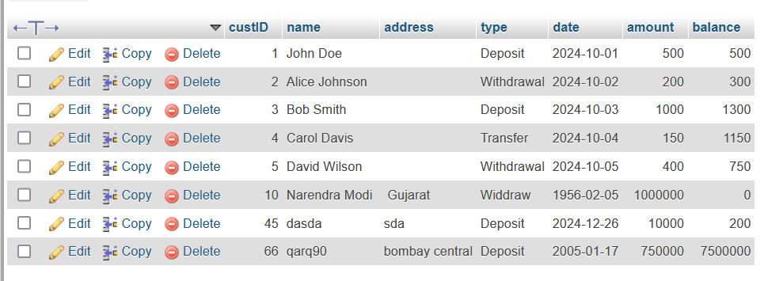

ADDING A CUSTOMER (CODE)

private void showCustomerAdd(Stage primaryStage) {  
 BorderPane customerAddPane = new BorderPane();  
  
 Label jLabel1 = new Label("Customer ID:");  
 TextField txtid = new TextField();  
  
 Label jLabel2 = new Label("Customer Name:");  
 TextField txtname = new TextField();  
  
 Label jLabel3 = new Label("Address:");  
 TextArea jTextArea1 = new TextArea();  
 jTextArea1.setPrefRowCount(3);  
 jTextArea1.setWrapText(true);  
  
 Label jLabel4 = new Label("Date (YYYY-MM-DD):");  
 TextField txtdate = new TextField();  
  
 Label jLabel5 = new Label("Type:");  
 ComboBox<String> lsttype = new ComboBox<>();  
 lsttype.getItems().addAll("Deposit", "Withdraw");  
  
 Label jLabel6 = new Label("Amount:");  
 TextField txtamount = new TextField();  
  
 Label jLabel7 = new Label("Balance:");  
 TextField txtbalance = new TextField();  
  
 Button cmdadd = new Button("Add Customer");  
 Button cmdclear = new Button("Clear Fields");  
 Button cmdexit = new Button("Exit");  
  
 cmdadd.setOnAction(e -> {  
 addCustomer(txtid, txtname, jTextArea1, txtdate, lsttype, txtamount, txtbalance);  
 });  
 cmdclear.setOnAction(e -> clearFields(txtid, txtname, jTextArea1, txtdate, lsttype, txtamount, txtbalance));  
 cmdexit.setOnAction(e -> primaryStage.close());  
  
 VBox inputPane = new VBox(10);  
 inputPane.setPadding(new Insets(20));  
 inputPane.getChildren().addAll(  
 new Label("New Customer Registration") {{  
 setStyle("-fx-font-size: 24; -fx-text-fill: red;");  
 }},  
 new HBox(10, jLabel1, txtid),  
 new HBox(10, jLabel2, txtname),  
 new HBox(10, jLabel3, jTextArea1),  
 new HBox(10, jLabel4, txtdate),  
 new HBox(10, jLabel5, lsttype),  
 new HBox(10, jLabel6, txtamount),  
 new HBox(10, jLabel7, txtbalance),  
 new HBox(10, cmdadd, cmdclear, cmdexit) {{  
 setAlignment(javafx.geometry.Pos.CENTER);  
 }}  
 );  
  
 customerAddPane.setCenter(inputPane);  
  
 Scene customerAddScene = new Scene(customerAddPane, 800, 600);  
 Stage customerAddStage = new Stage();  
 customerAddStage.setTitle("Customer Add");  
 customerAddStage.setScene(customerAddScene);  
 customerAddStage.show();  
}  
  
private void addCustomer(TextField txtid, TextField txtname, TextArea jTextArea1, TextField txtdate,  
 ComboBox<String> lsttype, TextField txtamount, TextField txtbalance) {  
 try {  
 Class.forName("com.mysql.cj.jdbc.Driver");  
 Connection con = DriverManager.getConnection("jdbc:mysql://localhost:3306/dbms", "root", "");  
 PreparedStatement ps = con.prepareStatement("INSERT INTO bank VALUES (?, ?, ?, ?, ?, ?, ?)");  
 ps.setInt(1, Integer.parseInt(txtid.getText()));  
 ps.setString(2, txtname.getText());  
 ps.setString(3, jTextArea1.getText());  
 ps.setString(4, txtdate.getText());  
 ps.setString(5, lsttype.getValue());  
 ps.setDouble(6, Double.parseDouble(txtamount.getText()));  
 ps.setDouble(7, Double.parseDouble(txtbalance.getText()));  
 ps.executeUpdate();  
 clearFields(txtid, txtname, jTextArea1, txtdate, lsttype, txtamount, txtbalance);  
 showAlert("Success", "Customer added successfully!");  
 } catch (Exception e) {  
 showAlert("Error", "Could not add customer: " + e.getMessage());  
 e.printStackTrace();  
 }  
}  
  
private void clearFields(TextField txtid, TextField txtname, TextArea jTextArea1, TextField txtdate,  
 ComboBox<String> lsttype, TextField txtamount, TextField txtbalance) {  
 txtid.clear();  
 txtname.clear();  
 jTextArea1.clear();  
 txtdate.clear();  
 lsttype.setValue(null);  
 txtamount.clear();  
 txtbalance.clear();  
}  
  
private void showAlert(String title, String message) {  
 Alert alert = new Alert(Alert.AlertType.INFORMATION);  
 alert.setTitle(title);  
 alert.setHeaderText(null);  
 alert.setContentText(message);  
 alert.showAndWait();  
}

VIEWING CUSTOMERS (CODE)

private void showViewCustomer(Stage primaryStage) {  
 Label lblTitle = new Label("View Customer Details");  
 lblTitle.setFont(Font.*font*("Tahoma", FontWeight.*BOLD*, 24));  
 lblTitle.setTextFill(Color.*rgb*(204, 0, 0));  
  
 TableView<Customer> tableView = new TableView<>();  
  
 TableColumn<Customer, Integer> colCustId = new TableColumn<>("CustId");  
 colCustId.setCellValueFactory(cellData -> new SimpleIntegerProperty(cellData.getValue().getCustId()).asObject());  
  
 TableColumn<Customer, String> colName = new TableColumn<>("Name");  
 colName.setCellValueFactory(cellData -> new SimpleStringProperty(cellData.getValue().getName()));  
  
 TableColumn<Customer, String> colAddress = new TableColumn<>("Address");  
 colAddress.setCellValueFactory(cellData -> new SimpleStringProperty(cellData.getValue().getAddress()));  
  
 TableColumn<Customer, String> colType = new TableColumn<>("Type");  
 colType.setCellValueFactory(cellData -> new SimpleStringProperty(cellData.getValue().getType()));  
  
 TableColumn<Customer, String> colDate = new TableColumn<>("Date");  
 colDate.setCellValueFactory(cellData -> new SimpleStringProperty(cellData.getValue().getDate()));  
  
 TableColumn<Customer, Double> colAmount = new TableColumn<>("Amount");  
 colAmount.setCellValueFactory(cellData -> new SimpleDoubleProperty(cellData.getValue().getAmount()).asObject());  
  
 TableColumn<Customer, Double> colBalance = new TableColumn<>("Balance");  
 colBalance.setCellValueFactory(cellData -> new SimpleDoubleProperty(cellData.getValue().getBalance()).asObject());  
  
 tableView.getColumns().addAll(colCustId, colName, colAddress, colType, colDate, colAmount, colBalance);  
  
 ObservableList<Customer> data = FXCollections.*observableArrayList*(  
 new Customer(1, "John Doe", "", "Deposit", "2024-10-01", 500.0, 500.0),  
 new Customer(2, "Alice Johnson", "", "Withdrawal", "2024-10-02", 200.0, 300.0),  
 new Customer(3, "Bob Smith", "", "Deposit", "2024-10-03", 1000.0, 1300.0),  
 new Customer(4, "Carol Davis", "", "Transfer", "2024-10-04", 150.0, 1150.0),  
 new Customer(5, "David Wilson", "", "Withdrawal", "2024-10-05", 400.0, 750.0),  
 new Customer(10, "Narendra Modi", "Gujarat", "Withdrawal", "1956-02-05", 1000000.0, 0.0),  
 new Customer(45, "dasda", "sda", "Deposit", "2024-12-26", 10000.0, 200.0),  
 new Customer(66, "qarq90", "bombay central", "Deposit", "2005-01-17", 750000.0, 7500000.0)  
 );  
  
 tableView.setItems(data);  
  
 VBox vbox = new VBox(10, lblTitle, tableView);  
 vbox.setPadding(new Insets(15));  
  
 Scene scene = new Scene(vbox, 800, 600);  
 primaryStage.setScene(scene);  
 primaryStage.setTitle("View Customer");  
 primaryStage.show();  
}

VIEWING CUSTOMERS

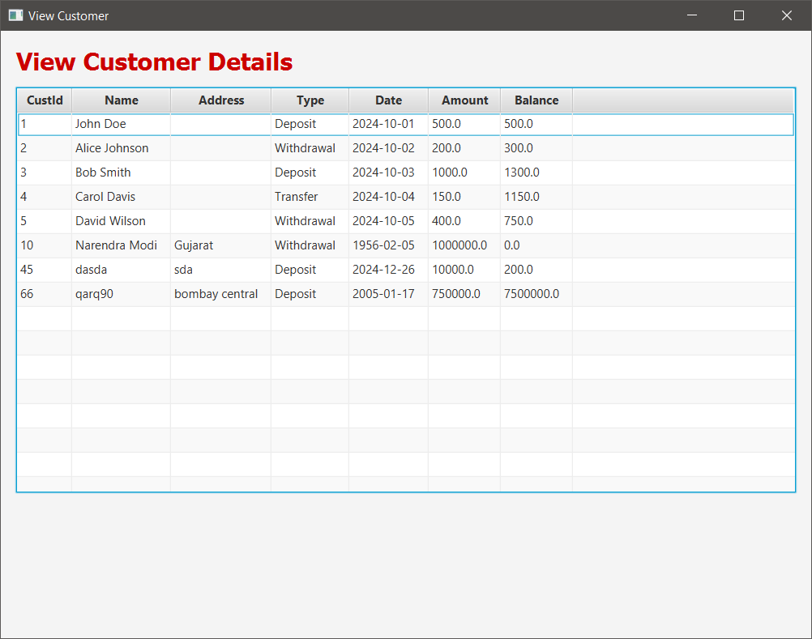

VIEWING CUSTOMERS’S BALANCE

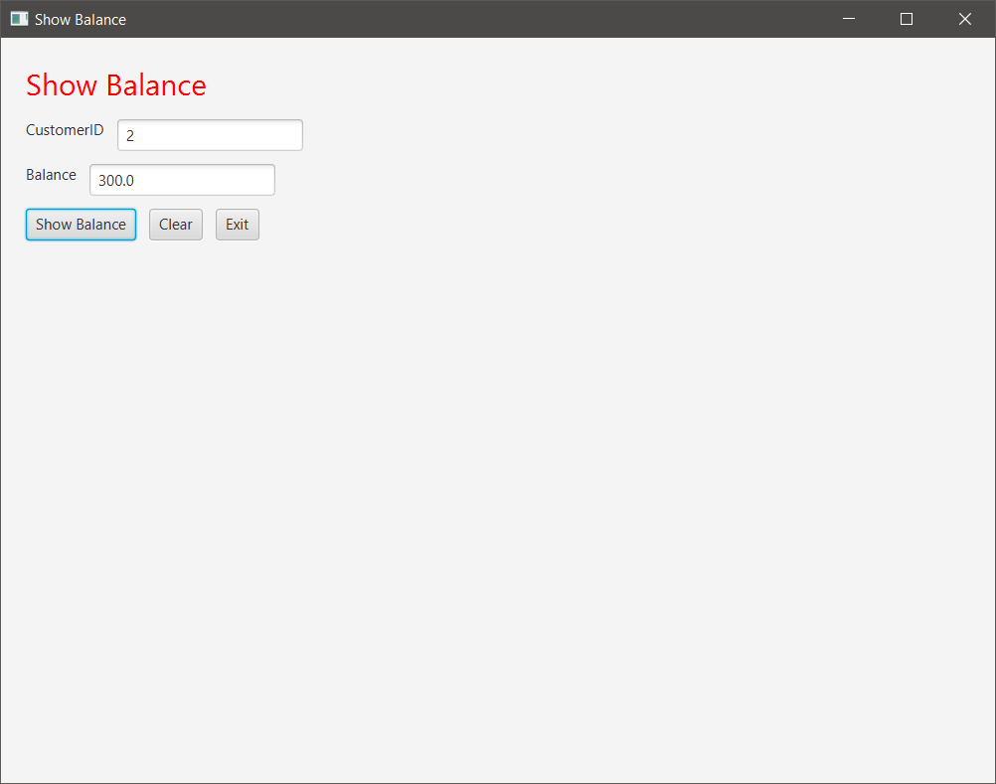

VIEWING CUSTOMERS’S BALANCE (CODE)

private void showShowBalance(Stage primaryStage) {  
 VBox showBalanceLayout = new VBox(10);  
 showBalanceLayout.setPadding(new Insets(20));  
  
 Label titleLabel = new Label("Show Balance");  
 titleLabel.setStyle("-fx-font-size: 24; -fx-text-fill: red;");  
  
 Label jLabel1 = new Label("CustomerID");  
 TextField txtcuid = new TextField();  
  
 Label jLabel2 = new Label("Balance");  
 TextField txtbal = new TextField();  
 txtbal.setEditable(false);  
  
 Button jButton1 = new Button("Show Balance");  
 Button jButton2 = new Button("Clear");  
 Button jButton3 = new Button("Exit");  
  
 jButton1.setOnAction(e -> {  
 try {  
 Class.*forName*("com.mysql.cj.jdbc.Driver");  
 Connection con = DriverManager.*getConnection*("jdbc:mysql://localhost:3306/dbms", "root", "");  
 Statement stmt = con.createStatement();  
 ResultSet rs = stmt.executeQuery("SELECT * FROM bank WHERE custid=" + *txtcuid*.getText());  
 double cbalance = 0;  
 while (rs.next()) {  
 cbalance = rs.getDouble(7);  
 }  
 *txtbal*.setText("" + cbalance);  
 } catch (Exception ex) {  
 ex.printStackTrace();  
 }  
 });  
  
 jButton2.setOnAction(e -> {  
 *txtcuid*.setText("");  
 *txtbal*.setText("");  
 });  
  
 jButton3.setOnAction(e -> *primaryStage*.close());  
  
 showBalanceLayout.getChildren().addAll(titleLabel,  
 new HBox(10, jLabel1, txtcuid),  
 new HBox(10, jLabel2, txtbal),  
 new HBox(10, jButton1, jButton2, jButton3));  
  
 Scene showBalanceScene = new Scene(showBalanceLayout, 800, 600);  
 Stage showBalanceStage = new Stage();  
 showBalanceStage.setTitle("Show Balance");  
 showBalanceStage.setScene(showBalanceScene);  
 showBalanceStage.show();  
}